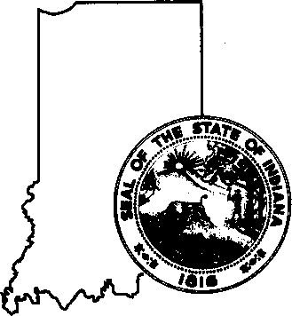
STATE OF INDIANA DEPARTMENT OF FINANCIAL INSTITUTIONS
30 South Meridian St.
Suite 200 Indianapolis, Indiana
46204-2759
(317) 232-3955
(800) 382-4880
www.in.gov/dfi

Department of Financial Institutions 2026 Indiana General Assembly Legislation of Interest Summary

The following is a summary of legislation adopted by the 2026 Indiana General Assembly, which may interest the Indiana Department of Financial Institutions (“DFI”), its constituencies, staff, and Members. For additional information regarding any bill, the complete list of all legislation enacted or considered by the 2026 Indiana General Assembly may be found here. The DFI did not have an agency bill in the 2026 legislative session; however, there were still several bills that impacted the Department and its regulated entities.

The summary below is not an exhaustive review of the bills, and interested parties are encouraged to review all provisions of the legislation and the newly enacted statutes in greater detail. While this publication intends to provide DFI-regulated industries, trade associations, attorneys, and the public with an overview of recently enacted legislation over which the DFI has regulatory and administrative authority, businesses are encouraged to seek legal counsel with questions regarding how the new laws may impact a particular business model or product.

SEA 169—Reorganization of Consumer Lending Laws

This bill repeals the statutes governing first lien mortgage lending (IC 24-4.4), the Uniform Consumer Credit Code (“UCCC”) (IC 24-4.5), including small loans, mortgage rescue protection fraud, and home loan practices. It recodifies the repealed statutes in a new title of the Indiana Code, Title 37. The bill did not contain any substantive changes to the UCCC or other laws. Rather, the intent of the bill was a recodification. While there is broad language recognizing that contracts and other documents entered into under the old law are considered references to the new code citations, affected entities will need to review relevant documents and make updated code citations.

HEA 1116—Virtual Currency Kiosk Ban

This bill prohibits the operation of a virtual currency kiosk in Indiana. The bill was first introduced as a new regulatory scheme that would have required the DFI to regulate virtual currency kiosks. However, as the bill advanced in the Senate, the language was amended to become a ban. The law was declared an emergency and was effective upon passage. As a result, virtual currency kiosks have been banned in Indiana since March 9, 2026. Indiana was the first state to pass such a ban, but there have now been other states following Indiana’s lead.

OTHER BILLS OF INTEREST THAT WERE INTRODUCED BUT FAILED TO PASS

HB 1215—Regulation of Interchange Fees

This bill would have limited payment card networks and depository institutions from implementing certain fee schedules that have been used by other card issuers. The bill would also have restricted fees from being imposed on the portions of a payment transaction attributable to a tax, tax exempt product, regulatory fee, or gratuity. While this bill did not pass, the DFI will continue to monitor for other legislation in this area and monitor litigation surrounding this issue and a similar bill that was passed in Illinois.

HB 1217—Regulation of Stablecoin

This bill would have established a state path for stablecoin issuers to be licensed by the DFI. The bill mirrored language in the Federal GENIUS Act, which established a framework for regulating payment stablecoin issuers. The bill ultimately failed to pass, but the DFI is continuing conversations and watching for any future legislation in this area.

SB 289—Public Depositories

This bill attempted to modify the requirements for depositories to be eligible to receive public deposits—allowing public entities to deposit public funds at institutions that are geographically further away from the public institution. The bill did not pass but the DFI continues to provide information to relevant parties as requested.

